Daniel DeCarlo

Box # 107

Cairn University School of Business

CIS122 Essentials of Networking

Project # 4

Project objective:

The purpose of this project is to set up an efficient and strong network in a newly developed workspace. This network floor plan will help show how the network will be set up and designed so it can create the most effective and efficient working environment. The floor plan includes where the pieces of equipment and wires will be. The plan can help network technicians see what kind of equipment and how the network is set up so repairs can be made fast.

Equipment used:

|  |  |  |  |  |
| --- | --- | --- | --- | --- |
| Equipment Description | Vendor | Vendor Item # | Retail price | Actual price (if known) |
| Router | Amazon  Ubiquiti EdgeRouter PRO (ERPro-8) 8-Port Router with 2 Combination SFP/RJ45 Ports  by [Ubiquiti Networks](https://www.amazon.com/Ubiquiti-Networks/b/ref=bl_dp_s_web_8938872011?ie=UTF8&node=8938872011&field-lbr_brands_browse-bin=Ubiquiti+Networks)  (https://www.amazon.com/Ubiquiti-EdgeRouter-ERPro-8-8-Port-Combination/dp/B00IA5J8M8/ref=sr_1_1?fst=as%3Aoff&qid=1551067168&refinements=p_n_feature_keywords_browse-bin%3A5502990011&rnid=7150431011&s=pc&sr=1-1) | ERPRO-8 | $349.03 |  |
| Wireless access points | Ubiquiti Networks UAP-AC-PRO-US Unifi 802.11ac Dual-Radio PRO Access Point (6 Items)  Ubiquiti Networks Unifi 802.11ac Dual-Radio PRO Access Point (UAP-AC-PRO-US) | UAP-AC-PRO | 6 pack 789.89  1 pack 133.40  Total:923.29 |  |
| Ethernet Cables | VIVO Blue 1,000 ft Bulk Cat5e Ethernet Cable/Wire UTP Pull Box 1,000ft Cat-5e Style (CABLE-V001B) | CABLE-V001B | $46.99 |  |
| Switches | Amazon  Cisco SF200-48P Smart Switch: 48 10/100 Ports, PoE, 2 Combo Mini-GBIC Ports (SLM248PTNA)  (https://www.amazon.com/dp/B004GHMU56) | SLM248PT-NA | $893.86 |  |
| Equipment Cabinet | StarTech RK812WALLO 8U Open Frame Wall Mount Equipment Rack - 12-Inch Deep (Black)(https://www.amazon.com/StarTech-RK812WALLO-Frame-Mount-Equipment/dp/B001VSR9SG/ref=sr_1_1_sspa?keywords=equipment+rack&qid=1551068268&refinements=p_n_feature_six_browse-bin%3A1265302011&rnid=1265276011&s=electronics&sr=1-1-spons&psc=1) | RK812WALLO | $103.78 |  |
| Network Copiers | Brother Monochrome Laser Printer, Multifunction Printer and Copier, DCP-L5500DN, Flexible Network Connectivity, Duplex Printing, Mobile Printing & Scanning, Amazon Dash Replenishment Enabled  (https://www.amazon.com/Brother-Multifunction-DCP-L5500DN-Connectivity-Replenishment/dp/B01BHSLIN6/ref=sr_1_3?keywords=network+copier&qid=1551150757&s=electronics&sr=1-3) | DCP-L5500DN | $234.98 x 4 =  $939.92 |  |
| 1-9 Meter Fiber optic cable- OM1 Multimode LC to LC | Show ME Cables  https://www.showmecables.com/by-category/cables/fiber-optic/lc-lc-62-5-125-multimode-duplex-fiber-patch-cable-om1 | SKU  34-507-02M | $9.49 |  |

Detailed list of software and operating platforms used, including version numbers and licensing requirements:

Only software needed is anything with command prompt.

Network diagram: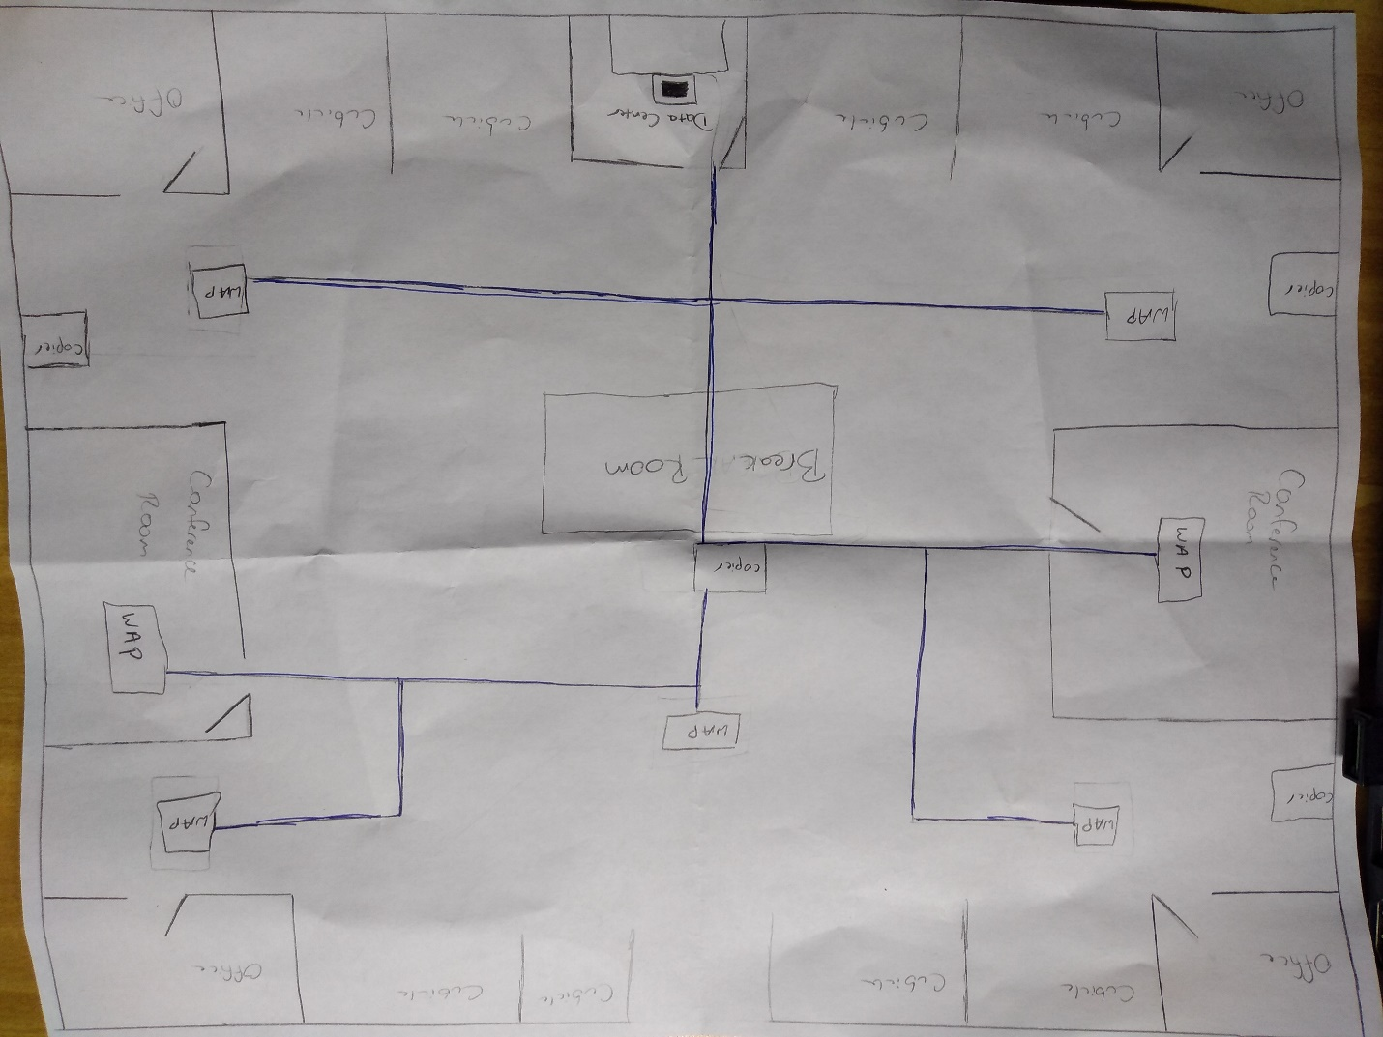

(if you can’t read this I can give you a hard copy)

Configurations:

1. Research and purchase the appropriate equipment needed for establishing a physical network. Make sure the floor plan is well detailed and contains information of where certain rooms are going to be and the dimensions of the floor.
2. Make sure you establish a data center and that the equipment needed is stored in that room with the correct environment settings. The data center should have the equipment rack and on the rack should be the router, switch, and a computer to check on the data center.
3. Plug everything in to an outlet or power strip. The switch should be hooked up to the router with a fiber optic cable. Use the LC cables to connect the router and the switch.
4. Then create your Ethernet cables with rj-45 connectors. The Ethernet cables will run from the switch to the wireless access points.
5. Place the wireless access points on the desired locations according to the floor plan. Run the Ethernet cables from the datacenter and the switch to the wireless access points.
6. Make sure the network connection is established and that everything is working properly.
7. Connect the Copiers to the network and perform tests to make sure they work efficiently.
8. Run the troubleshooter if there are any issues and use the command prompt with the functions PING with the IP address to make sure there is a successful connection.